P530/2

Biology

Paper 2

July/August 2019

2½ hours

**BUGANDA EXAMINATIONS COUNCIL MOCKS**

**Uganda Advanced Certificate of Education**

**BIOLOGY**

**PAPER 2**

**2HOURS 30 MINUTES**

**INSTRUCTIONS TO CANDIDATES:**

* Answer all questions in section **A** and any **three** in section **B**.

**SECTION A**

1. The figures below represent the number of white fly larvae on cabbage leaves for 30 days after spraying with non specific pesticide, **DDT**.

**DDT** affects adult white flies whose larvae destroy the cabbage leaves and are predated on by garden beetles.

Figure **A** is obtained after one application of **DDT**.

Figure **B** is obtained after repeated application of **DDT.**

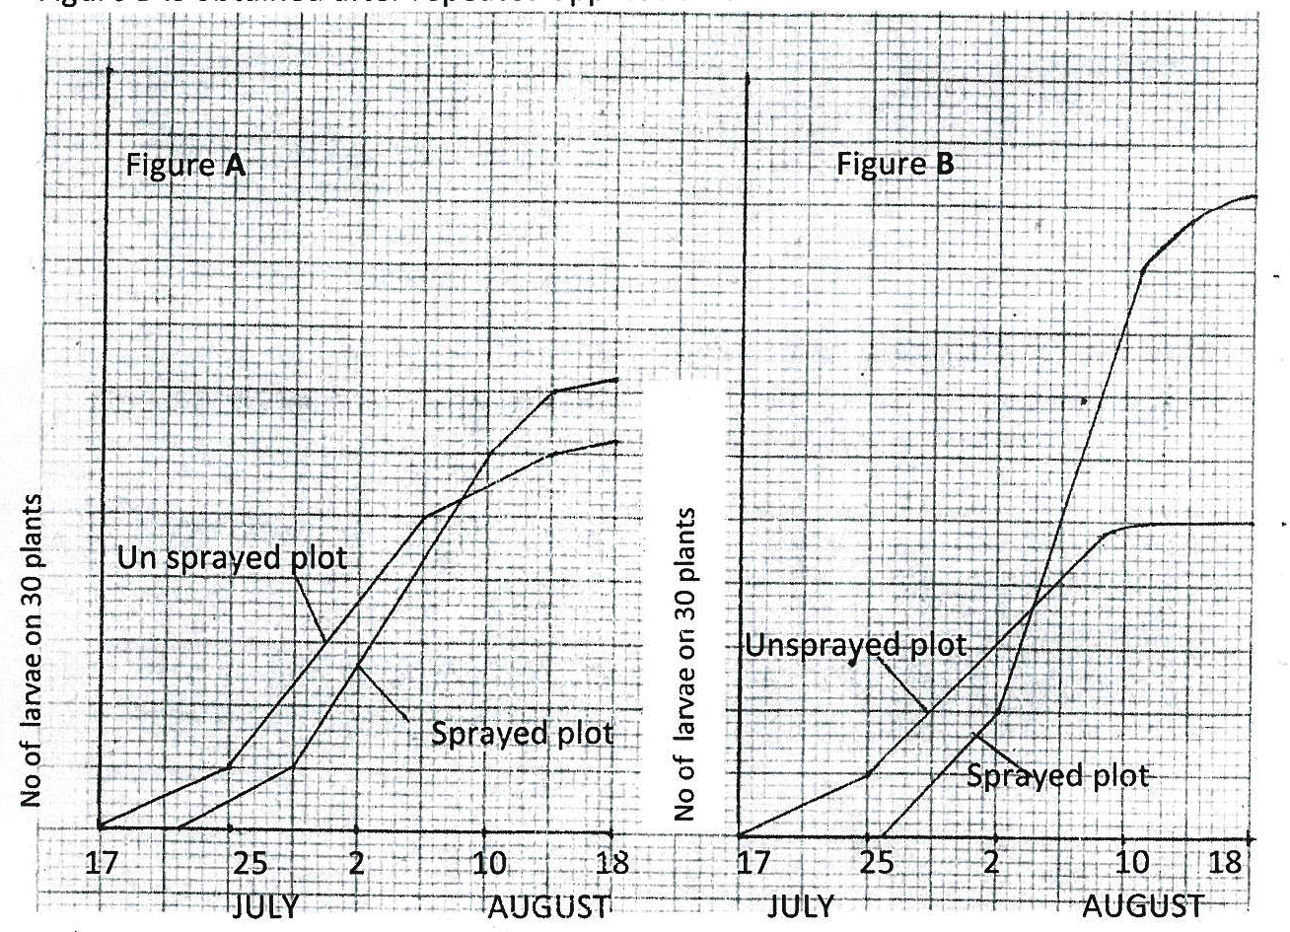

(a) Describe the changes in larvae number in figure **A** and **B**. (14marks)

(b)(i) Compare changes in number of larvae in unsprayed and sprayed plots of figure **A**.

(8marks)

(ii) Explain the differences in changes of larvae number described above. (7marks)

(c)(i) Explain the differences in larvae number changes between sprayed plots of figure **A** and **B**. (6marks)

(ii) From the graph explain the effect of persistent use of pesticides. (5marks)

**SECTION B**Answer any ***three*** questions.

2(a) What is the role of Gibberellins and IAA in plant growth. (10marks)

(b) Explain how a plant regulates water loss in hot weather. (10marks)

3(a) What is counter current system? (2marks)

(b) Compare counter current multiplier of kidney tubules with counter current flow in the limbs of temperate animals. (12marks)

(c) What is the significance of counter current system in animals? (6marks)

4. Explain the effects of fire;

(i) to biotic factors (10marks)

(ii) to soil fertility in an ecosystem (10marks)

5(a) Explain how temperature affects enzyme activity. (10marks)

(b) Explain how amount of competitive inhibitor affects the rate of reaction. (10marks)

6(a) Describe how xylem structure is related to its function. (10marks)

(b) Explain how human body responds to dehydration. (10marks)

**END**